**Summarization:**

**Note: To list all the branches, use ‘git branch’ command**

**Step 1: Navigate to project git folder**

**Step 2: Create a new branch**

$git branch TC_101

**Step 3: Checkout this branch**

$git checkout TC_101

**Step 4: Make some changes corresponding to this branch in eclipse**

**Step 5: Add changes**

$git add –-all

**Step 6: Commit the changes**

$git commit –m “changes”

**Step 7: Switch to master branch**

$git checkout master

**Step 8: Merge the branch**

$git merge TC_101

Step 9: Delete the branch

**$git branch –D TC_101**

**Step 10: Push changes to remote repository**

$git push https://github.com/hkumar7878/sportsappium.git master

Note: Check steps summarization at the end of document

Steps to create a new branch, switching, merging with master and then deleting it.

***Step 1:***

Navigate to local project git folder and issue command as shown below:

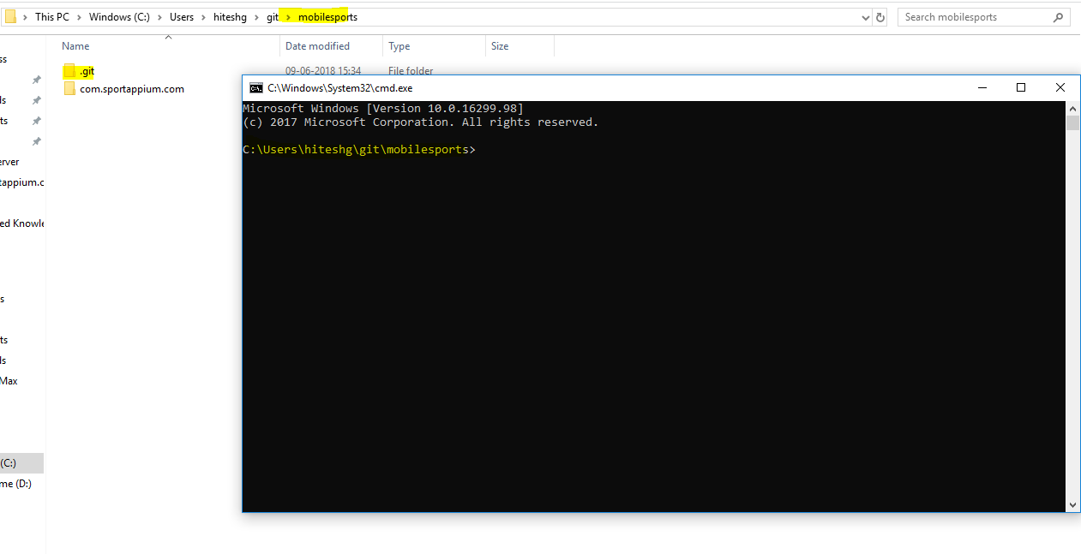

**Step 2:**

Firstly, we need to create a new branch

Issue the following command to create a new branch

***$ git branch TC_101***

This ‘**branch** ‘command will create a new branch.

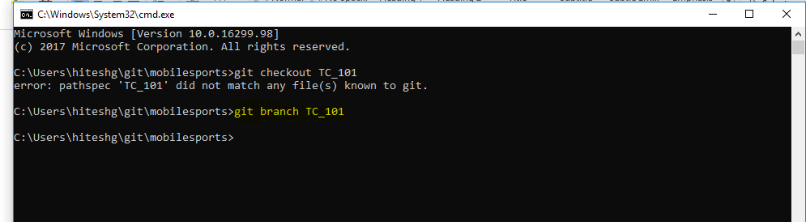

This command will also create a new branch in eclipse as well.

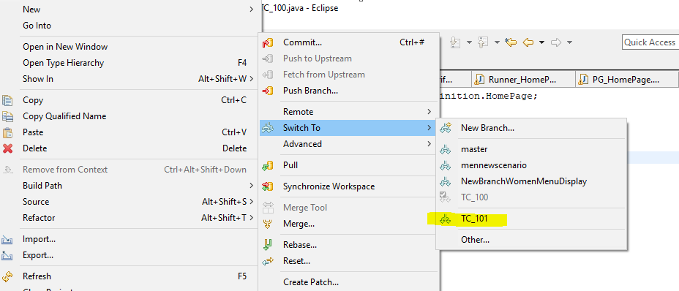

**Step 3:**

Now switch to new branch to start working on that branch by issuing the following command

$ git checkout TC_101

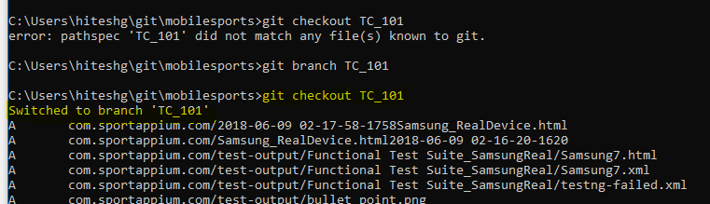

If we open eclipse, then we can also see that user is switched to this new branch

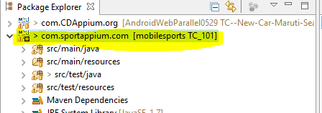

**Step 4:**

Now do some changes in eclipse say create a new dummy class as follow:

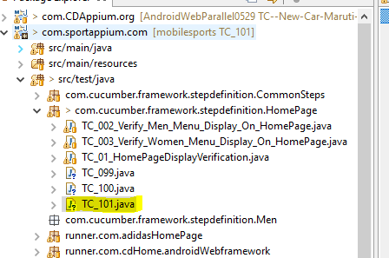

Step 5:

Now commit the step 4 changes into new branch by issuing the following two commands

$git add –all

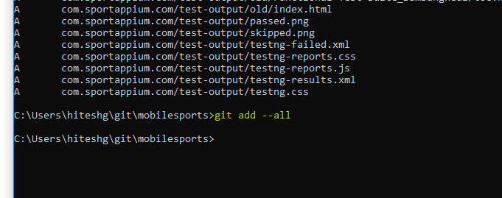

$ git commit –m “TC_101 Changes”

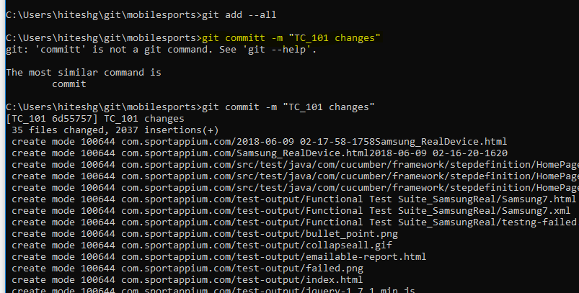

Step 6: Now switch to master branch

$git checkout master

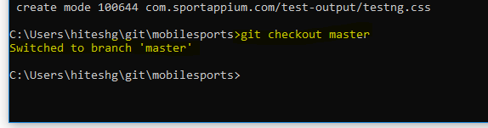

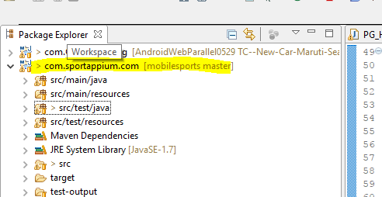

Step 6: Now switch back to new branch

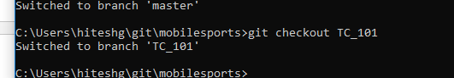

Step 8: Merge the new branch changes to the master branch.

In order to merge with the master, first we need to switch to master branch

$git checkout master

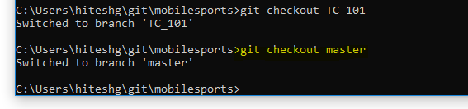

Now issue the following merge command to merge the branch into master branch

$git merge TC_101

Now, the branch will be merged into master

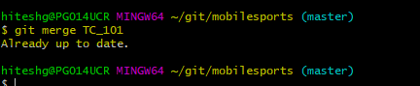

Go to eclipse, check the changes in master branch

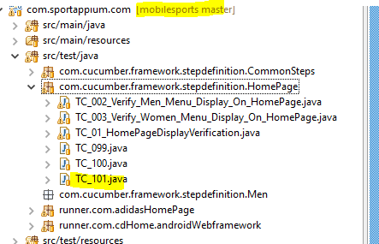

Step 10: Once done with the branch completion, delete it

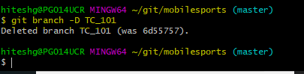

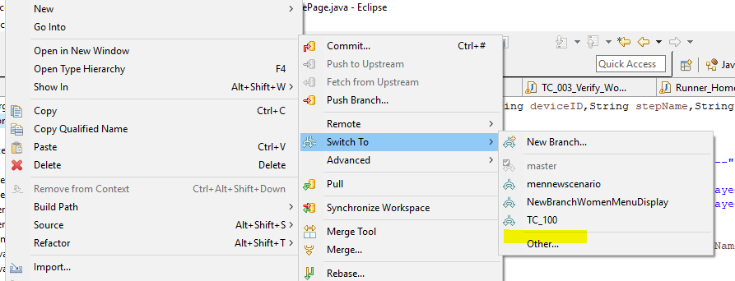

Step 11: Now push this branch changes to master branch in git repository

$git push https://github.com/hkumar7878/sportsappium.git master

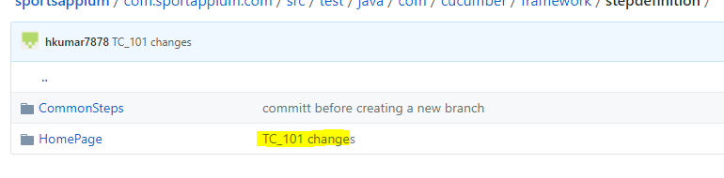

Note: Make sure to provide the remote repository URL while pushing the local master branch